Burham, Kent

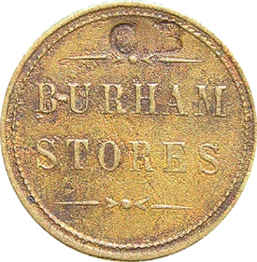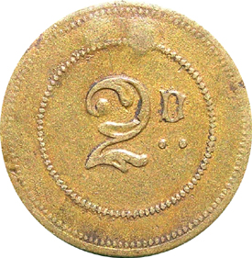
Brass, 23.4 mm, milled edge.

Having found that Burham was in Kent from my Gazetteer I contacted a Duncan Pennock (who lives in Kent) and he provided the following information:

No entry in the directories for 1903 or 1922 bur a Charles Bolton is listed for 1913 – 1918 as a grocer and running the Post Office. These are dividend tokens where you can accumulate money (similar to present day loyalty cards),
Interestingly this token was purchased in an antiques centre in LANCASTER.

Additional information was also provided from Duncan when a penny token was offered for sale in::

Mailbid Catalogue, No.17, Dec 14 2000 Simmons
Burham Stores ctm C B rev. 1D in wreath brass 24mm. VF £5-£10 Unclear whether this is a name or a locality.

Lime works
I also sent images of the lime works token and again Duncan came back with

List Number 2 June 2005
8256 | Burham | S Brice Lime Works Burham / 4 incuse Truck filling | £60.00
8257 | Burham | S Brice Lime Works Burham / 2 incuse Truck filling | £50.00

This from the “Tokens for Sale “ catalogue and included this illustration,

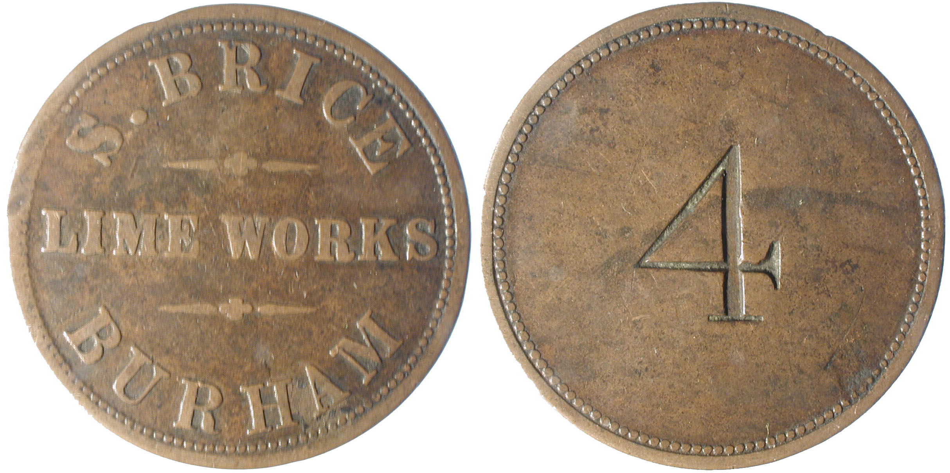

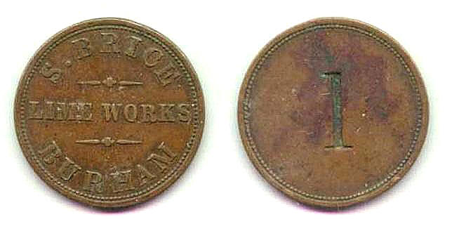
From the website

Wouldham Cement Co.
No. (1535)
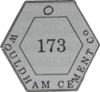

Brass, 38mm across the flats, hexangonal, plain edge.

O: Around the rim is: WOULDHAM CEMENT C^{O} and in the centre is the number 173, (incuse), holed at the top. (Grays Local History Lib.)

This token is listed in mt book “The Essex Collection of post 1820 tokens, tallies and medallions” (1993) which at the moment I am up dating. As a result I will remove this from the Essex entries.
I thought that as it was in Grays Local History Library that it was a local piece and would explain why I could not trace the company in the Essex directories.

